Supplementary Files

Efficient anchoring of Erianthus arundinaceus chromatin introgressed into sugarcane by novel specific molecular markers
Yongji Huang^{1†}, Jiayun Wu^{2†}, Xueting Li¹, Fan Yu¹, Xuguang Hu¹, Ling Luo¹, Muqing Zhang³, Liangnian Xu¹, Zuhu Deng^{1, 3, 4*}
¹National Engineering Research Center for Sugarcane, Fujian Agriculture and Forestry University, Fuzhou, Fujian, China
²Guangdong Key Laboratory of Sugarcane Improvement and Biorefinery, Guangdong Provincial Bioengineering Institute, Guangzhou, China
³State Key Laboratory for Protection and Utilization of Subtropical Agro-bioresources, Guangxi University, Nanning, China
⁴Key Lab of Sugarcane Biology and Genetic Breeding, Ministry of Agriculture, Fujian Agriculture and Forestry University, Fuzhou, China
† Equal contributors
* Correspondence:
Zuhu Deng
dengzuhu@163.com

Supplementary Figures
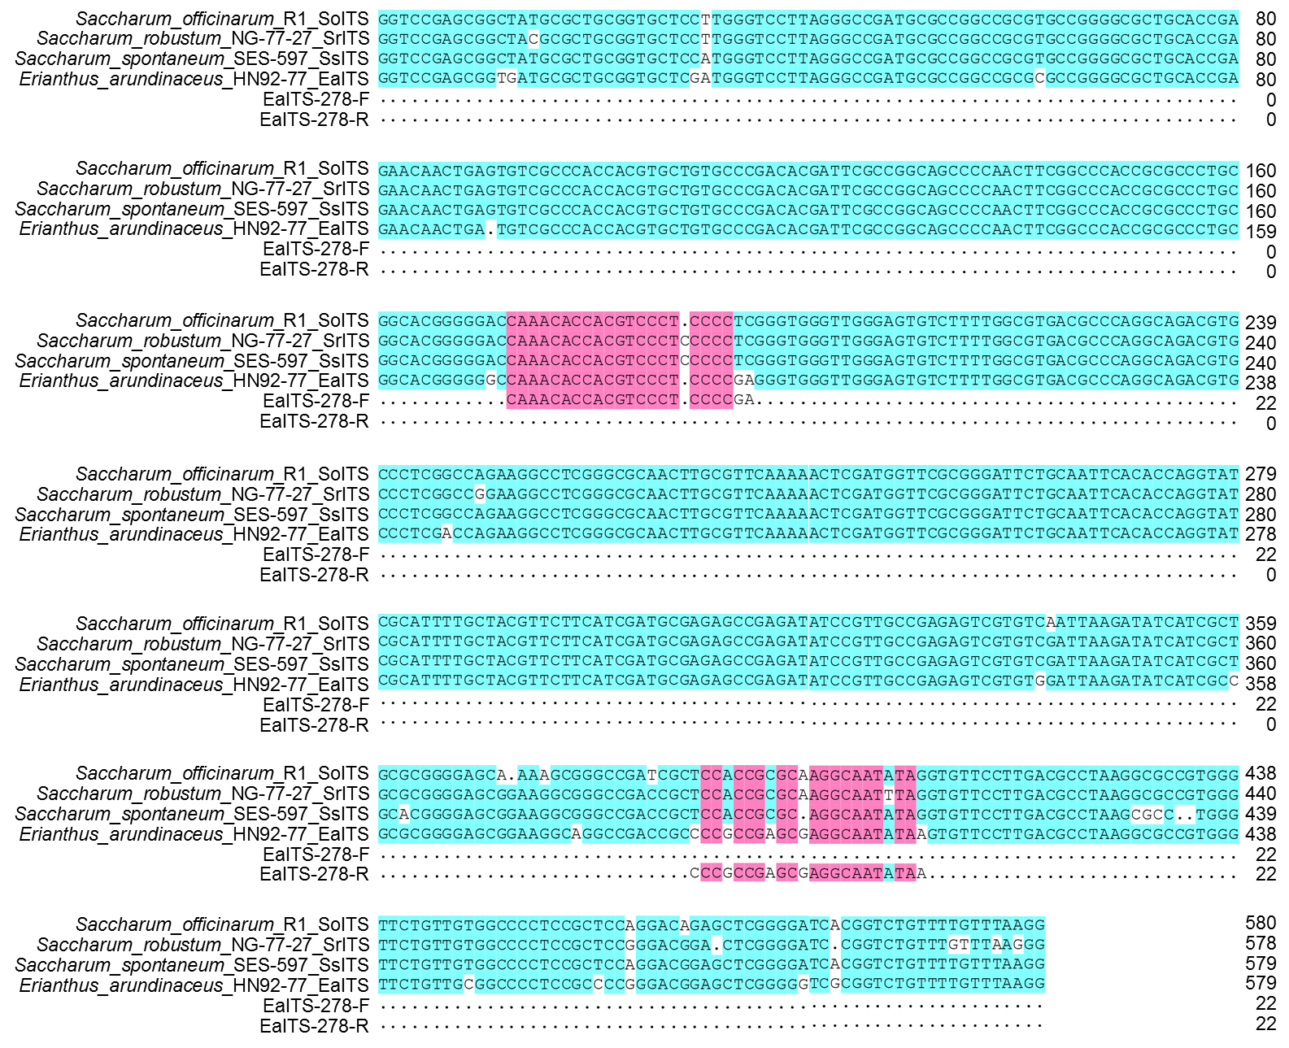
Figure S1. The multiple sequence alignment of 45S rDNA ITS sequences from S. officinarum, S. robustum, S. spontaneum, and E. arundinaceus as well as the position of the EaITS primer pairs (EaITS-278F and EaITS-278-R).

Supplementary Tables

Table S1. Clones of E. arundinaceus and sugarcane
No. | Clones | Species
1 | HN92-77 | E. arundinaceus
2 | HN92-105 | E. arundinaceus
3 | YN82-30 | E. arundinaceus
4 | YN82-80 | E. arundinaceus
5 | YN83-180 | E. arundinaceus
6 | Badila | S. officinarum
7 | Crystallina | S. officinarum
8 | Black Cheribon | S. officinarum
9 | Lothers | S. officinarum
10 | Luohanzhe | S. officinarum
11 | 51NG63 | S. robustum
12 | NG77-004 | S. robustum
13 | 57NG208 | S. robustum
14 | 51NG3 | S. robustum
15 | Daye | S. robustum
16 | YN75-2-11 | S. spontaneum
17 | YN82-50 | S. spontaneum
18 | FJ92-1-11 | S. spontaneum
19 | FJ89-1-18 | S. spontaneum
20 | FJ89-1-19 | S. spontaneum
21 | Yongshengzhe | S. sinense
22 | Wenshanzhe | S. sinense
23 | Uba | S. sinense
24 | Tanzhou Zhuzhe | S. sinense
25 | Guangxi Zhuzhe | S. sinense
26 | Katha | S. barberi
27 | Nagans | S. barberi
28 | Pansahi | S. barberi
29 | Saretha | S. barberi
30 | Mungo | S. barberi
31 | R570 | Cultivars
32 | ROC22 | Cultivars
33 | CP84-1198 | Cultivars
34 | F172 | Cultivars
35 | ROC10 | Cultivars

Table S2. Clones of F₁, BC₁, BC₂ and BC₃ between sugarcane and E. arundinaceus
No. | Clones | Generation
1 | YCE96-43 | F₁
2 | YCE96-45 | F₁
3 | YCE95-41 | F₁
4 | YCE96-66 | F₁
5 | YCE96-40 | F₁
6 | YCE01-33 | BC₁
7 | YCE01-46 | BC₁
8 | YCE01-48 | BC₁
9 | YCE01-63 | BC₁
10 | YCE01-99 | BC₁
11 | YCE01-102 | BC₁
12 | YCE01-105 | BC₁
13 | YCE01-116 | BC₁
14 | YCE01-134 | BC₁
15 | YCE01-36 | BC₁
16 | YCE01-92 | BC₁
17 | YCE01-61 | BC₁
18 | YCE01-69 | BC₁
19 | YCE03-01 | BC₂
20 | YCE03-06 | BC₂
21 | YCE03-16 | BC₂
22 | YCE03-168 | BC₂
23 | YCE03-218 | BC₂
24 | YCE03-249 | BC₂
25 | YCE03-378 | BC₂
26 | YCE04-55 | BC₂
27 | YCE05-179 | BC₂
28 | YCE05-64 | BC₃
29 | YCE05-150 | BC₃
30 | YCE06-63 | BC₃
31 | YCE06-61 | BC₃
32 | YCE06-92 | BC₃
33 | YCE06-111 | BC₃
34 | YCE06-140 | BC₃
35 | YCE06-166 | BC₃

Table S3. Putative BC₄ progeny between sugarcane and E. arundinaceus
No. | Cross combination | Female parent | Male parent
1 | CP89-2143 × YCE06-61 | CP89-2143 | YCE06-61
2 | CP94-1100 × YCE06-61 | CP94-1100 | YCE06-61
3 | HoCP01-564 × YCE06-61 | HoCP01-564 | YCE06-61
4 | GT00-122 × YCE06-61 | GT00-122 | YCE06-61

Table S4. Primer sequence
Primer | Sequence (5’-3’) | Length (bp)
adaptor 1 | CTAATACGACTCACTATAGGGCTCGAGCGGCCGC  CCGGGCAGAG | 44
adaptor 2R | CTAATACGACTCACTATAGGGCAGCGTGGTCGCG  GCCGAGAG | 42
28S-F | GTGCATTAAGTGTGGAGA | 18
28S-R | TAGGCTCCTTCTCGAGCTCT | 20
primer 1 | TCGAGCGGCCGCCCGGGCAGAG | 22
primer 2R | AGCGTGGTCGCGGCCGAGAG | 20
Ea086-128-F | TAGTAGTGCGTCGGGTCA | 18
Ea086-128-R | CAAGGTTCGTGTTTATCT | 18
Ea009-257-F | GAATTGGGAATAGCGGGACT | 20
Ea009-257-R | CATCGGCTGTTCCTGGTAT | 19
EaITS-278-F | CAAACACCACGTCCCTCCCCGA | 22
EaITS-278-R | TTATATTGCCTCGCTCGGCGGG | 22

